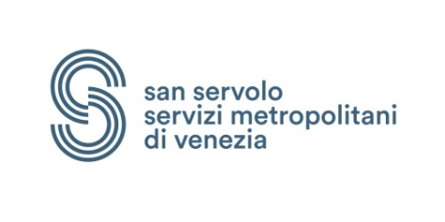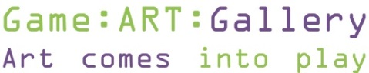

Neoludica International Show
INSIDE VIDEOGAME
Art . Programming . Workshops . Virtual reality . Development . Publishing
San Servolo Island, Venice, July 7-10, 2016
Curated by Debora Ferrari, Luca Traini, Gloria Vallese, Ivan Venturi

Neoludica INSIDE VIDEOGAME
General Program
Thursday 7
2:00 p.m. (within) Check-in at San Servolo
Exhibitions and events open at 2.00 p.m. (Game art, Academies, Developers, Italian events)
2.15 Meeting in the Auditorium for the general presentation and introduction of guests
2.30 to 7:00 p.m. Meeting-workshop with Academies and gurus in Auditorium
7:30 Dinner-party drink, Videogame music 9.00-12.00 pm​

Friday 8
Lab / Round table: Museums and gamification, Auditorium 9:30 to 12:30 // 2:00 p.m.-6:00 p.m.
Master Class with Italian gurus, MacLab room 9.00-12.00 // 13.00-16.00 // 4.00-7.00
Workshops Photography for videogame 8:30 to 12:30 / 4.00-8.00 with Paolo Della Corte, tour ‘Secret Venice’ in town, then back in
​Room 2: Workshops Videogame storytelling since 1976, with Luca Mazzocco,
​Room 7, from 2.00 to 6.00: Workshops Storytelling and videogaming with Pietro Parolin, Room 6, 10:00-12:00, 2:00-4:00, 4:00-6:00
Workshops Animation, Video 360°, with Holograms, MenteZero, Exhibition hall
Exhibitions game art, concept art, interactive installations, teams of developers
Laboratorio ARALE with MFLabs: 'With the mind move the world’, Exhibition hall
Saturday 9
Auditorium: Symposium of developers, with vision of new titles and panel discussion on development and publishing
Master class with Italian gurus 10-13 // 2:00-5:00 MacLab room
Workshop Mecha design of Star Wars with Francesco Frosi,
​Room 7, from 2:00 to 6:00: Workshop Retro but Gold: Vintage Sound VS Contemporary Gear, with Ivan Zora, Room 6, 4 hours, 2:00-6:00.
Workshop Kinect, Video 360°, VR, Holograms with MenteZero, Exhibition hall
Exhibitions game art, concept art, interactive installations, development teams, focusing on the proposals of the Academies and Mentezero study-and-work
Vg and app developers for gamification and new titles, networking
Laboratorio ARALE with MFLabs: 'With the mind move the world', Exhibition hall

Sunday 10
Morning of the Gurus, Auditorium 10-12.00 Raphael Lacoste, Ubisoft Paris AD, and Mauro Perini, Ubisoft Milan AD.12:00-13:00 AESVI4Dev and Drago D'Oro
Conclusion, delivery of diploms.
Farewell toast, check-out and departure.

www.neoludica.eu

